**ANT AND GRASSHOPPER**

It is the short story of an ant and grasshopper. The ant is hard working but grasshopper is lazy. One day in summer season the ant was collecting food for her family then the grasshopper saw the ant and laugh at her then ant said the grasshopper that please collect the food for winter season but grasshopper was not do this.

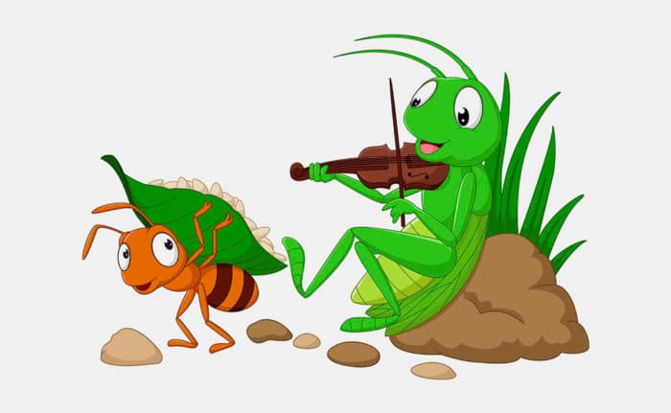Winter come the ant was lying cozily in his home the grasshopper comes near the ant and request the ant for food then ant said I was warn you before the winter for collecting the food but you not collect the food for you.

[*So, we should plane our future.*](https://in.video.search.yahoo.com/yhs/search?fr=yhs-sz-002&ei=UTF-8&hsimp=yhs-002&hspart=sz&param1=1226744063&p=ant+and+grasshopper+story&type=type80160-3464885101#id=1&vid=604ddeb4cdfdd9c36817c9a3b7feaafa&action=click)

|  |  |  |  |  |  |
| --- | --- | --- | --- | --- | --- |
|  |  |  |  |  |  |
|  |  |  |  |  |  |
|  |  |  |  |  |  |
|  |  |  |  |  |  |
|  |  |  |  |  |  |
|  |  |  |  |  |  |
|  |  |  |  |  |  |

**

*O*

*nce upon a time, two girls named Atiya and Priya lived in a hostel. Both of them did not know each other. After that one day Atiya went to Priya's room, near her sister, Atiya said angrily to her sister that why were you not receiving my call. Then Priya said angrily if she will not receive it, so what should you do then Atiya said no*

*If Atiya said not to receive, then ok I am going, Priya said go, then Atiya went to her room in anger, after that Priya's sister Sapna was peeled that you spoke like this and explained, then after some time Priya said Atiya to say sorry to Priya but Atiya did not money. After that Priya started crying, then Atiya got mercy and she agreed.*



*Thankyou*

